SIG ACHIEVES PLATINUM RATING IN LATEST ECOVADIS ASSESSMENT
SIG ranked among top 1% for
Corporate Responsibility
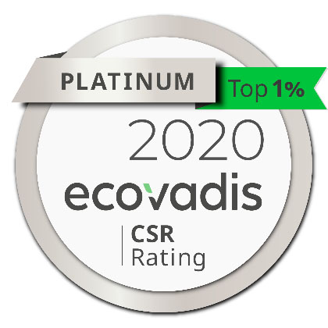

SIG has maintained its elite position among the top 1% of participating companies with a platinum rating in the latest EcoVadis assessment on corporate social responsibility (CSR).

„The platinum rating from EcoVadis is testament to SIG’s ongoing commitment to go Way Beyond Good for society and the environment,” said Michael Hecker, Director Corporate Responsibility at SIG. “Being ranked among the top 1% of companies for sustainability once again makes us very proud of what we have achieved and will inspire us to go even further.”

The EcoVadis assessment process is designed to improve transparency and promote continuous improvement on sustainability in the supply chain, enabling customers to monitor performance and identify high performing partners. The assessment methodology is based on international sustainability standards and supervised by a scientific committee of CSR and supply chain experts.

To date, EcoVadis has assessed over 50,000 trading partners worldwide. SIG first achieved its top percentile position in 2017. Since then, the company has improved its overall score as it continues to drive progress towards its ambition to go Way Beyond Good by putting more into society and the environment than it takes out.

Scores are based on a detailed independent assessment of policies, processes and performance related to the environment, labour and human rights, ethics and sustainable procurement criteria that are most relevant to the company’s size, location and industry.

Recognised external assessments like EcoVadis provide customers and other stakeholders with independent assurance that SIG is a responsible business. All SIG’s production plants also complete regular SEDEX (Supplier Ethical Data Exchange) Members Ethical Trade Audits to assess working conditions, health and environmental protection, and ethical business practices.

FIND OUT MORE ABOUT SIG’S WAY BEYOND GOOD COMMITMENT:
https://www.sig.biz/en/responsibility/way-beyond-good

READ SIG’S CORPORATE RESPONSIBILITY REPORT:
https://cms.sig.biz/media/4974/sig-corporate-responsibility-report-2018.pdf

About SIG
SIG is a leading systems and solutions provider for aseptic packaging. We work in partnership with our customers to bring food products to consumers around the world in a safe, sustainable and affordable way. Our unique technology and outstanding innovation capacity enable us to provide our customers with end-to-end solutions for differentiated products, smarter factories and connected packs, all to address the ever-changing needs of consumers.
Founded 1853, SIG is headquartered in Neuhausen, Switzerland. The skills and experience of our approximately 5,500 employees worldwide enable us to respond quickly and effectively to the needs of our customers in over 60 countries. In 2019, SIG produced more than 38 billion carton packs and generated €1.8 billion in revenue. For more information, visit www.sig.biz.

PICTURE CAPTION:
SIG has maintained its elite position among the top 1% of participating companies with a platinum rating in the latest EcoVadis assessment on corporate social responsibility (CSR).
Photo: SIG

YOUR Contact:
Heike Thevis
Press Officer

Tel.: +49 (0)2462 79 2608
Email: heike.thevis@sig.biz

SIG International Services GmbH

Visit us on www.sig.biz or on our blog at signals.sig.biz

